Cats Flehmen : Understanding this fascinating reflex through behavioural science

If you live with a cat, you may have witnessed an intriguing scene: after sniffing an object, a smell, another animal, your cat raises its head, opens its mouth slightly, freezes its gaze and seems to “smile”.
No, they're not grimacing, they're not angry, and they're not letting you know that something smells bad.
They are analysing a smell using a reflex called flehmen. This behaviour, well known to ethologists, remains a mystery to many cat owners. In this article, we explain this fascinating phenomenon in detail.

What is flehmen?
Flehmen is an olfactory reflex observed in many species: cats, horses, big cats, goats, etc.
It is a universal behaviour in species that use chemical molecules to communicate.
For cats, it manifests itself through characteristic signs:

✔️ mouth slightly open
✔️ no visible tongue
✔️ lips slightly curled
✔️ short, silent breathing
✔️ unblinking gaze
✔️ head in an upright position

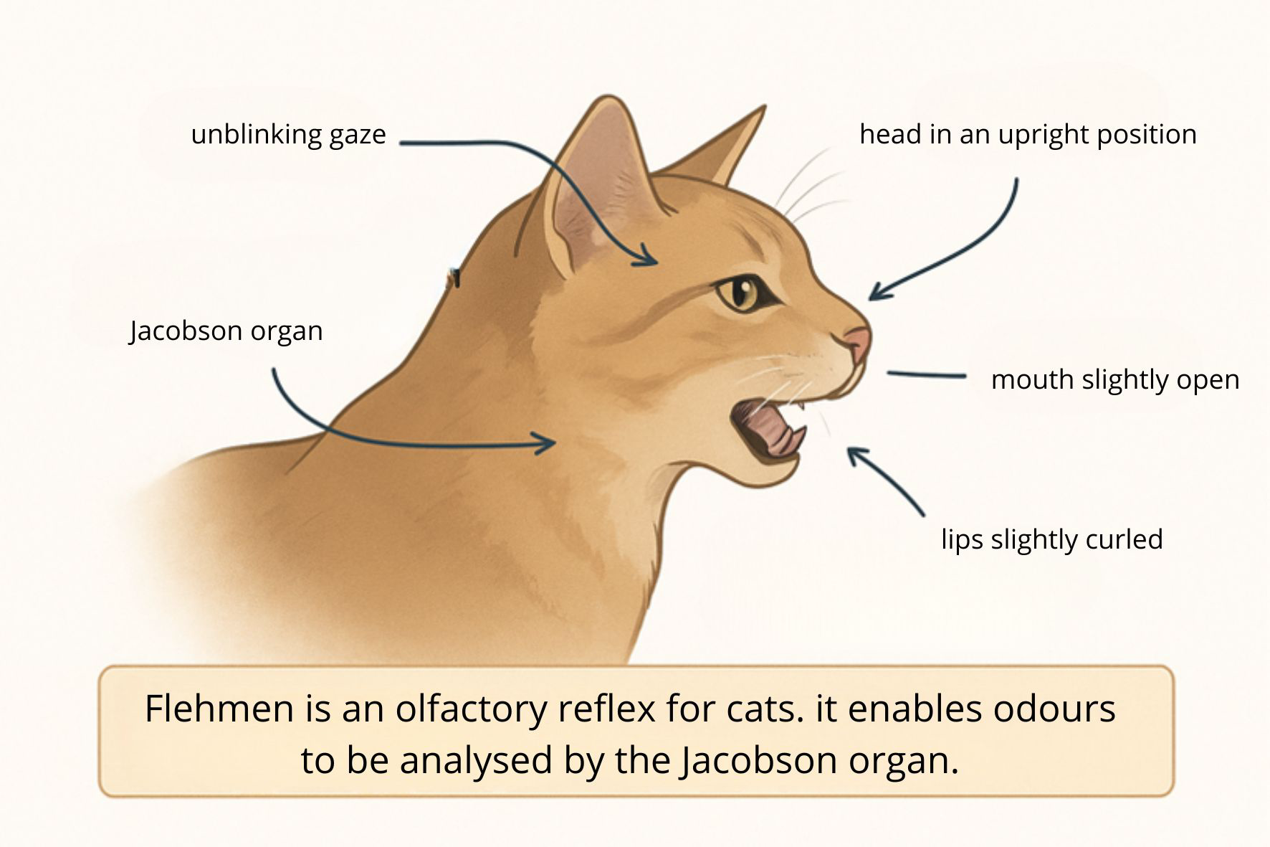

Contrary to popular belief, cats do not make a ‘stinky face’.
It is an intense sensory activity.
Unlike human facial expressions, it does not reflect any emotion: neither disgust nor aggression.
It is a chemical analysis mechanism, designed to obtain very precise information about the environment. You could say that they taste a smell, in a way.

A specific organ: the Jacobson's organ
To understand flehmen, we need to talk about a key element of the feline sensory system:
the vomeronasal organ, also known as the Jacobson's organ.
It is located between the palate and the nasal cavities, behind the upper incisors.
This organ detects very specific molecules such as:
• molecules,
• chemical markers,
• biological information about the condition of another animal.
We could say that the Jacobson's organ serves to ‘decode invisible messages’ present in the environment.

Why do cats use flehmen?
Flehmen occurs when cats encounter important olfactory information. Here are the most common situations:

1. Analysing the chemical molecules of another cat.
This is particularly the case with:
• urine marks,
• rubbing areas,
• facial chemical molecules left on furniture or humans.

2. Understanding another animal was here (cat, dog, other mammal)
Thanks to flehmen, cats can obtain information such as:
• identity,
• sex,
• reproductive status,
• emotional state,
• health status.

3. Exploring a new environment
A new bag, shoes, a cardboard box, an outside smell... everything is potentially a source of information.

A discreet superpower
With a sense of smell about 14 times more developed than that of humans, and a specialised organ to analyse chemical molecules, cats have a true ‘portable chemical laboratory’.
Flehmen is simply the gateway to this extraordinary system.
Watching your cat perform flehmen is a rare opportunity to witness one of the most essential senses at work in its social life.

A normal behaviour
Flehmen is not a sign of stress, pain or discomfort.
It is an innate, perfectly healthy behaviour for all cats, male and female, neutered or not.
There is no reason to worry if your cat does it frequently: it simply means that they are actively analysing their environment.

How should I react if my cat flehmen?
The best reaction is to let them get on with it.
During flehmen, cats are extremely focused. It is best to avoid:
• calling them,
• stroking them,
• trying to play with them.
Let them finish their sensory analysis. This usually lasts 1 to 4 seconds, rarely longer.

In summary
• Flehmen is not a grimace, but an advanced olfactory reflex.
• It relies on the Jacobson's organ, which is dedicated to the analysis of chemical molecules.
• It allows cats to understand their environment, other animals and certain human information.
• It is a normal, healthy and common behaviour.

